**CS512 Project Report**

**Image Inpainting**

**Based on the Fast Marching Method**

Jian Zhang A20327380

Yuan Gao A20331426

**Abstract**

Image inpainting is the technique of reconstructing small damaged portions of an image. When a “damaged” image is provided and we want to fix the “damaged” portions of it, we need to remove the pixels in these portions and fill these portions with proper pixels. These proper pixels are calculated based on adjacent pixels of the damaged parts. Based on the paper “An Image Inpainting Technique Based on the Fast Marching Method” written by Alexandru Telea in 2004, we use Fast Marching Method to deal with pixels. The Fast Marching Method explicitly separates the known from the unknown image area and specifies which pixel is the next pixel to inpaint. Given an image and the same size mask (which shows the portions to be inpainted), our program is able to inpaint the original image on the position shown in the mask and get the inpainted result.

**Keywords:** image inpainting, Fast Marching Method, mask

1. **Introduction**

Image inpainting is the technique of reconstructing small damaged portions of an image. Image inpainting is usually used in removing text and logos from still images, reconstructing scans of deteriorated images by removing scratches or stains, and creating artistic effects.

Given an image and a region inside it, the inpainting problem consists in modifying the image values of the pixels in the region so that this region does not stand out with respect to its surroundings. The purpose of inpainting might be to restore damaged portions of an image (e.g. an old photograph where folds and scratches have left image gaps) or to remove unwanted elements present in the image (e.g. a microphone appearing in a film frame).

When a “damaged” image is provided and we want to fix the “damaged” portions of it, we need to remove the pixels in these portions and fill these portions with proper pixels. These proper pixels are calculated based on adjacent pixels of the damaged parts. So this is an image inpainting algorithm we need.

So in this project, two inputs are needed. At first, the original image which is required to be inpainted. Then the portions which needs to be inpainted should be shown. So a same size mask image is also needed to show the portions to be inpainted.

According to the original “damaged” image and the mask, program should be able to inpaint the original image on the position shown in the mask and get the inpainted result.

1. **Proposed Solution**

As mentioned above, the problem is that: given an image and the same size mask (which shows the portions to be inpainted), our program should be able to inpaint the original image on the position shown in the mask and get the inpainted result.

So to solve this problem, we have the following proposed solution.

Step 1:

Deal with the mask and try to change the mask to binary image.

Step 2:

Use the information in the mask to judge which part in the original image is known area, which part is unknown area and which part is the bound between the two areas.

Step 3:

Use the algorithm in the method Fast Marching Method to calculate the priority value of each pixel on the bound.

Step 4:

After calculating the priority values, the data including the priority values of the pixels on the current bound is inserted into a data structure heap, waiting for the following process.

Step 5:

In the heap, find the pixel which has the smallest priority value. Try to calculate and inpaint that pixel using its adjacent known pixels’ data.

Step 6:

After inpainting the pixel in step 5, change that pixel to the known part and remove it from the heap. Then judge and change its adjacent pixel(s) in the unknown area to the bound pixel(s) and calculate their priorities.

Step 7:

Insert the data of new bound pixels into the heap.

Step 8:

Iteratively do the step 5, 6 and 7 until the heap becomes empty, which means that there is no bound in the image and that the inpainting of the original image is completed.

Step 9:

Write the data in the output file and get the result of the inpainting.

1. **Implementation Details**
2. **How to judge the bound**

In the algorithm, it is important to judge which pixel belongs to the bound. Generally, as we know, the bound should be the unknown pixel which stays between the known pixels and unknown pixels.

So the method used in the program is shown in Figure 1. For all the unknown pixels, a crossing shape is considered around the pixel to be determined. If there exists one known pixel in the four pixels around it, we can say that this pixel belongs to the bound. In Figure 1, the middle pixel is unknown and needs to be determined whether it belongs to the bound. For the left example, the top pixel in the crossing shape is known. So there exists one known pixel in the crossing shape, the middle pixel belongs to the bound. For the right example, all the four pixels in the crossing shape are unknown. So the middle pixel doesn’t belong to the bound and it is inside the unknown area.



**Figure 1: How to judge the bound pixel**

1. **How to inpaint a** **pixel**

The second important problem is how to inpaint the boundary pixel.

As shown in Figure 2, if we want to inpaint the boundary p, take a small neighborhood of the known image around p. The inpainting of p should be determined by the known image pixels close to p.



**Figure 2: How to inpaint a pixel**

In the algorithm, a small square neighbor area is selected. In the square, every known pixel is detected and the average value of the known pixels are calculated. So we get the inpainting data based on the adjacent pixels. This method is used iteratively in the program to inpaint all the unknown points in some order which is described in the next part.

1. **How to** **decide the inpainting order (****Fast Marching Method)**

This is the core part of this project. In fact, the most important in this project is how to separate the known from the unknown image area and specify which pixel is the next pixel to inpaint.

As the unknown area or the mask has random shapes, the determination of the sequence of inpainting must become the key consideration in this project.

In the last section, the method to inpaint a point on the unknown region’s boundary is explained. To inpaint the whole unknown area, that method can be iteratively used in all the pixels in the unknown area in increasing distance from the boundary’s initial position. What’s more, the boundary is advanced inside the unknown area until the whole region has been inpainted. Here is the pseudocode of the inpainting algorithm.

*B0 = boundary* *of region to inpaint*

*B = original boundary*

*while (B not empty)*

*{*

*p = pixel of B closest to B0*

*inpaint p*

*advance B into the unknown area*

*}*

Inpainting points in increasing distance order from original boundary makes sure that areas closest to known image points are filled in the first place. For propagating the boundary into the unknown area in this way, the Fast Marching Method is used.

The Fast Marching Method is a numerical method for solving boundary value problems of the Eikonal equation:

||=1 on unknown area, with T = 0 on the boundary

The solution T is a distance map of the unknown pixels to the boundary. The level sets of T are exactly the successive boundaries of the shrinking unknown area we need to paint. The Fast Marching Method guarantees that pixels are always processed in increasing order of their distance to boundary, and that we always inpaint the closest pixels to the known image area first.

The Fast Marching Method’s main advantage is that it explicitly maintains the narrow band that separates the known from the unknown image area and specifies which pixel is the next pixel to inpaint. Other distance transform methods compute the distance map but do not maintain an explicit narrow band. Adding a narrow band structure to these methods would complicate their implementation, whereas the Fast Marching Method provides this structure by default. The Fast Marching Method maintains a so-called narrow band of pixels, which is exactly our inpainting boundary.

For every image pixel, we store its value T, its image gray value I and a flag that have three values:

BAND: the pixel belongs to the narrow band. Its T value updates.

KNOWN: the pixel in the known image area. Its T and I values are known.

INSIDE: the pixel in the region to inpaint. Its T and I values are unknown temporarily.

At first, for the initialization of Fast Marching Method, T is set to 0 for known image area and the boundary. For the region to inpaint except the boundary, T is set to large value (106). The flag f is set as shown above. All BAND points are inserted in a heap NarrowBand sorted in the ascending order of their T values. Then based on the initialization, the following pseudocode is used to implement the Fast Marching Method.

*While (NarrowBand not empty)*

*{*

*extract P(i,j) = head(NarrowBand); /* Step 1 */*

*f(i,j) = KNOWN;*

*for (k,l) in (i-1,j),(i,j-1),(i+1,j),(i,j+1)*

*if (f(k,l)!=KNOWN)*

*{*

*if (f(k,l)==INSIDE)*

*{*

*f(k,l)=BAND; /* Step 2 */*

*inpaint(k,l); /\** *Step 3 */*

*}*

*T (k,l) = min(solve(k-1,l,k,l-1), /* Step 4 */*

*solve(k+1,l,k,l-1),*

*solve(k-1,l,k,l+1),*

*solve(k+1,l,k,l+1));*

*insert(k,l) in NarrowBand; /* Step 5 */*

*}*

*}*

*float solve(int i1,int j1,int i2,int j2)*

*{*

*float sol = 1.0e6;*

*if (f(i1,j1)==KNOWN)*

*if (f(i2,j2)==KNOWN)*

*{*

*float r = sqrt(2(T(i1,j1)T(i2,j2))*(T(i1,j1)T(i2,j2)));*

*float s = (T(i1,j1)+T(i2,j2)r)/2;*

*if (s>=T(i1,j1) && s>=T(i2,j2)) sol = s;*

*else*

*{ s += r; if (s>=T(i1,j1) && s>=T(i2,j2)) sol = s; }*

*}*

*else sol = 1+T(i1,j1));*

*else if (f(i2,j2)==KNOWN) sol = 1+T(i1,j2));*

*return sol;*

*}*

Here are the description of the import steps in this algorithm.

Step 1:

Extract the BAND point with the smallest T.

Step 2:

March the boundary inward by adding new points to it.

Step 3:

Perform the inpainting algorithm

Step 4:

Propagate the value T of point (i,j) to its neighbors (k,l) by solving the following Fast Marching Method equation (which is the finite difference discretization of the equation mentioned above)

max(D-xT, -D+xT, 0)2 + max(D-yT, -D+yT, 0)2=1

where

D−xT(i, j) = T(i, j)− T(i−1, j)

D+xT(i, j) = T(i+1, j)− T(i, j)

D−yT(i, j) = T(i, j)− T(i, j-1)

D+yT(i, j) = T(i, j+1)− T(i, j)

Step 5:

Insert (k,l) with its new T value in the heap.

1. **Result**
2. Women Example

Here is the original image.

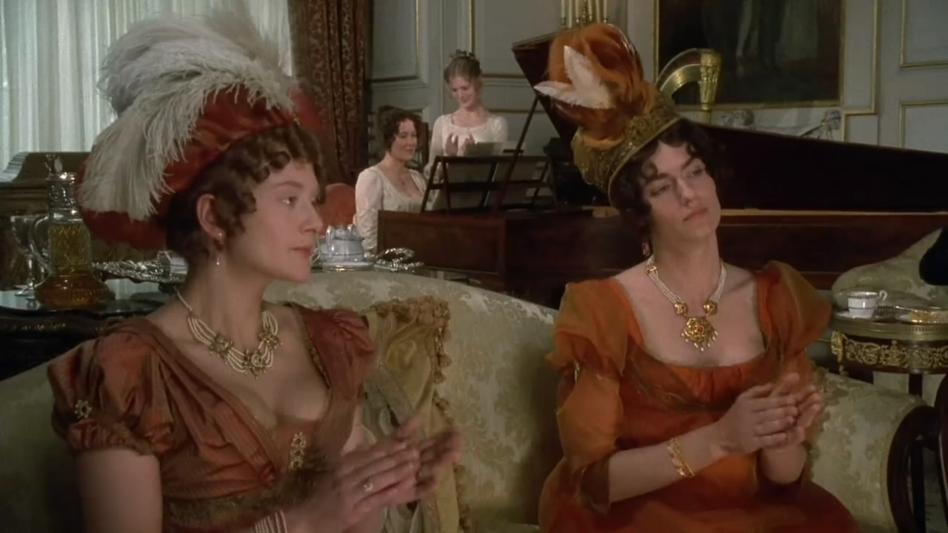

Here is the mask.



Here is the original “damaged” image.



Here is the inpainted image.

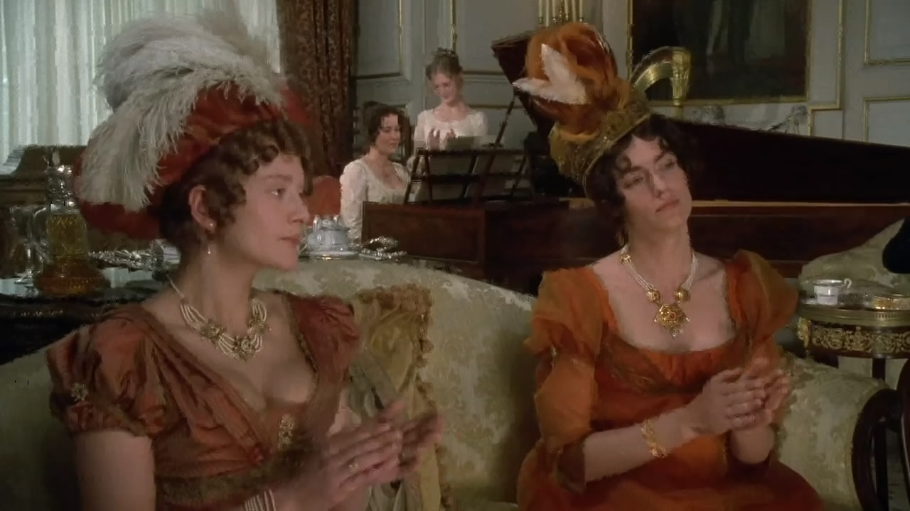

1. Car Example

Here is the original image.

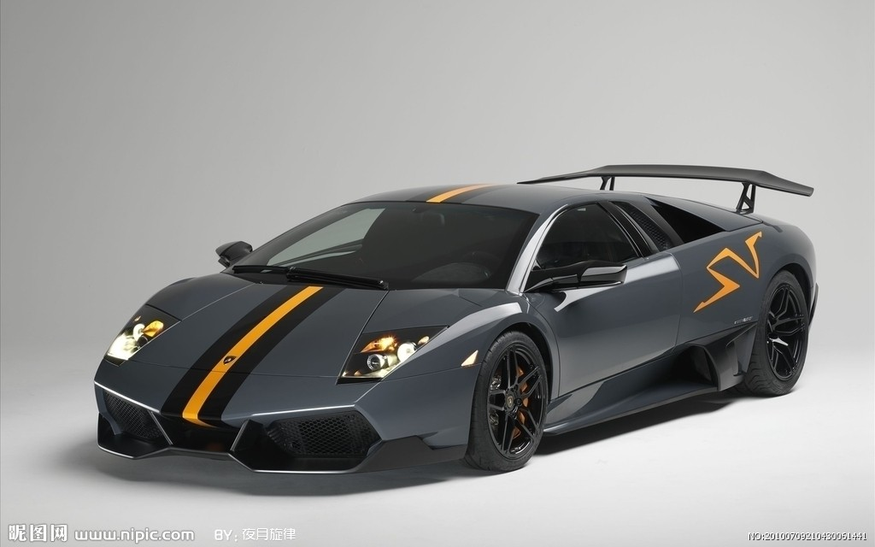

Here is the mask.

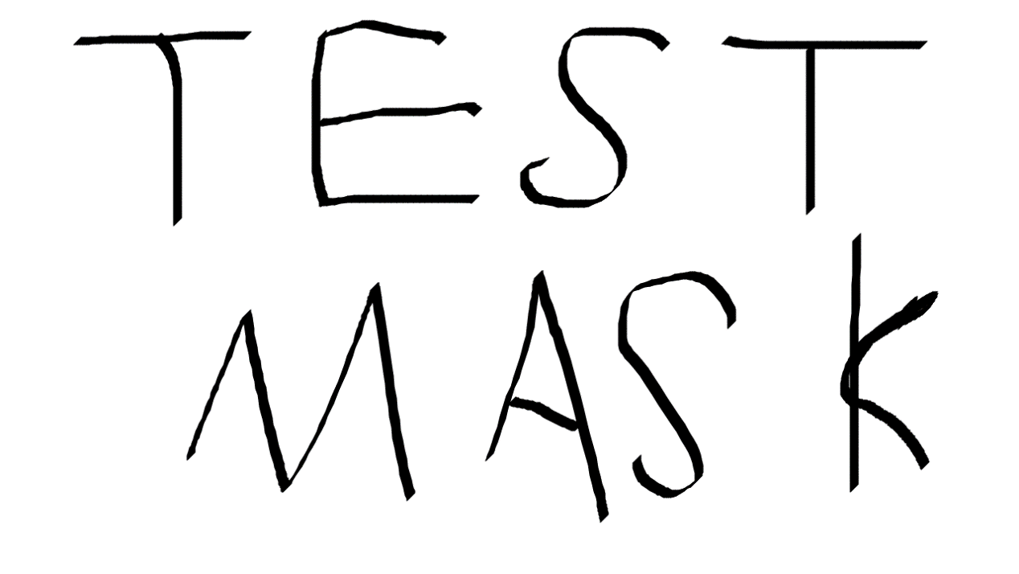

Here is the original “damaged” image.

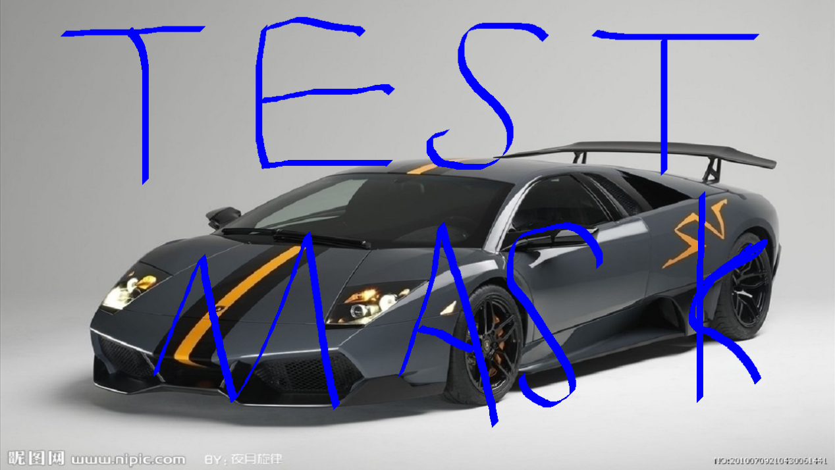

Here is the inpainted image.

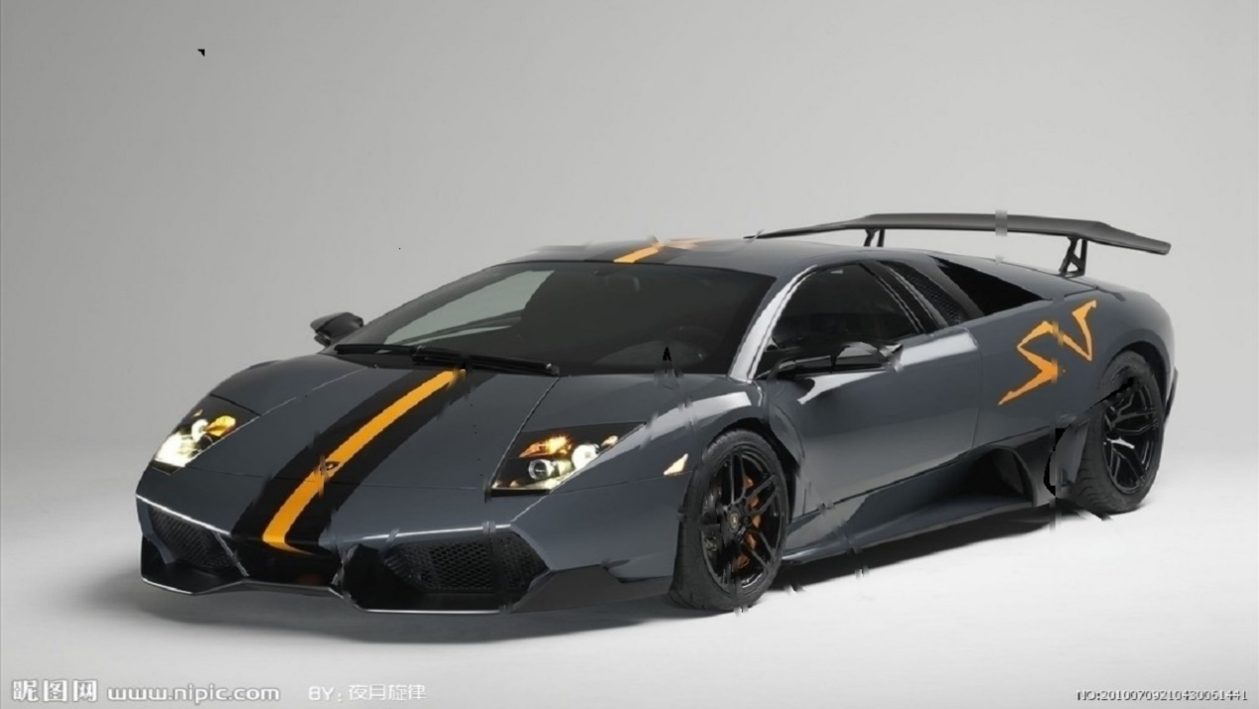

1. Beach Example

Here is the original image.



Here is the mask.

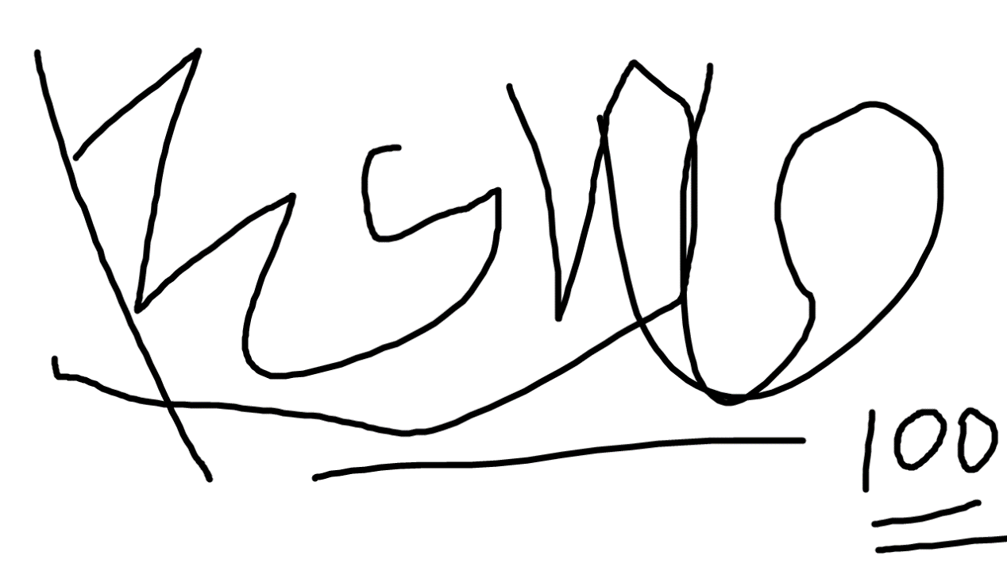

Here is the original “damaged” image.

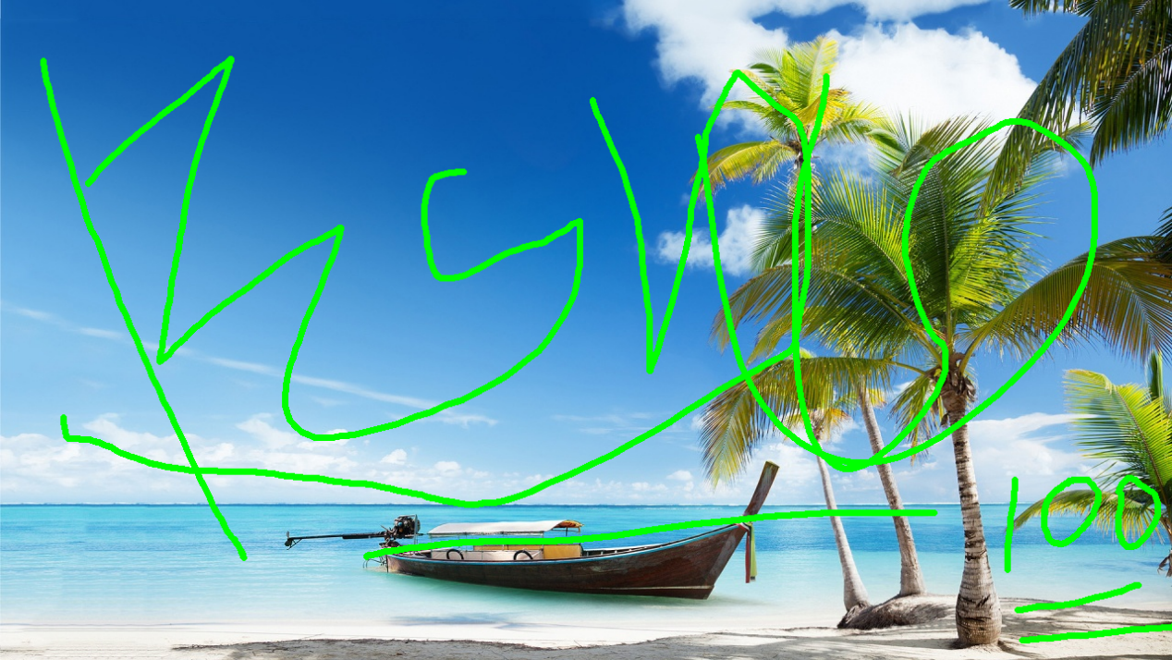

Here is the inpainted image.



1. **References**

[1]Alexandru Telea. An Image Inpainting Technique Based on the Fast Marching Method. Journal of graphics tools, 2004

[2]J. A. Sethian. Level Set Methods and Fast Marching Methods, Second edition. Cambridge, UK: Cambridge Univ. Press, 1999.

[3] http://www.birs.ca/workshops/2011/11w5086/files/Forcadel.pdf

[4]https://math.berkeley.edu/~sethian/2006/Explanations/fast_marching_explain.html

[5] <http://cermics.enpc.fr/~monneau/cimpa-tripoli-040611.pdf>

[6] <http://math.univ-lyon1.fr/~masnou/fichiers/publications/survey.pdf>

[7] <http://www.ahay.org/RSF/book/sep/fmeiko/paper_html/node2.html>